1 Install Beautiful Soup and Parser Element

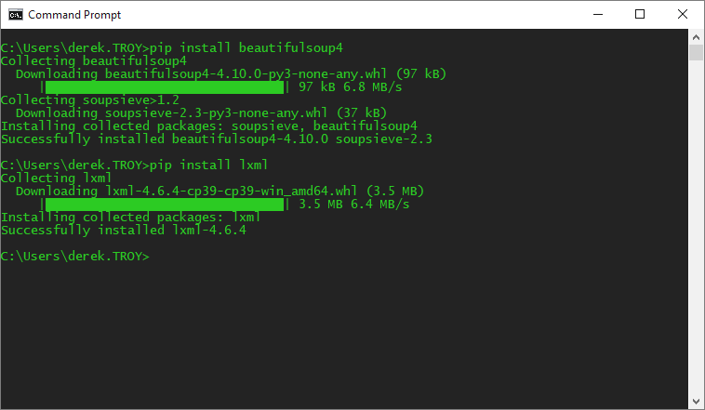

Installed XML Parser as this most minimal parser for Beautiful Soup